Shell script output for node health

Vim nodehealth.sh

Always write metadata infor as like below screenshot

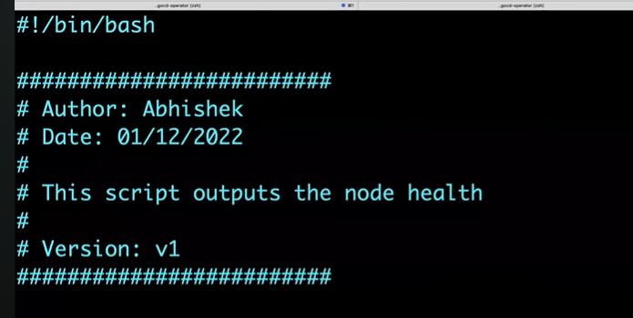

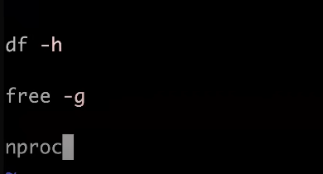

Chmod 777 nodehealth.sh

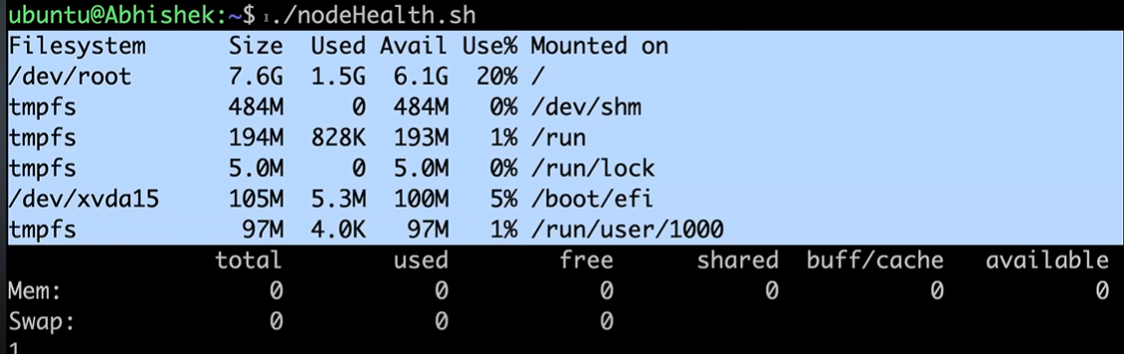

For proper output we need echo commands

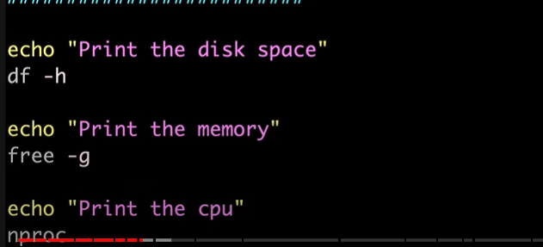

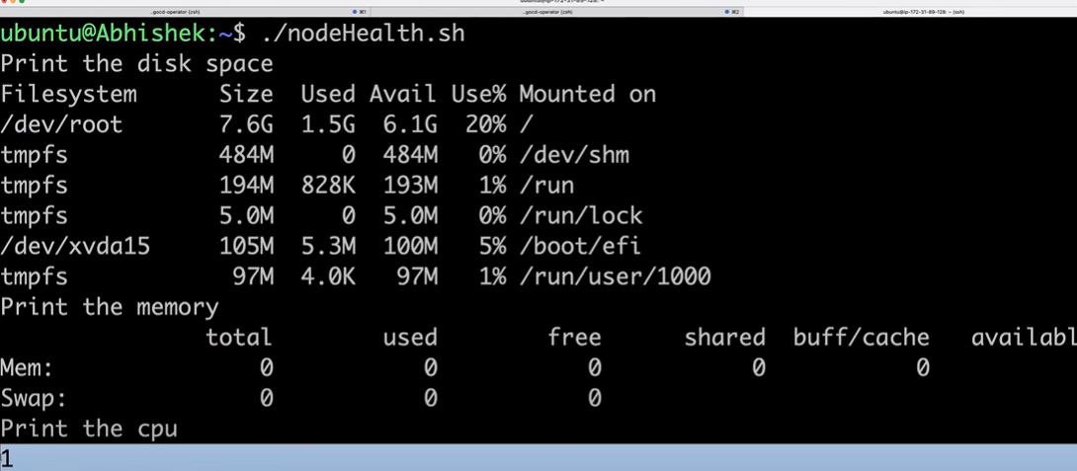

We cannot add echo always for all commands so we can add set -x #debug mode

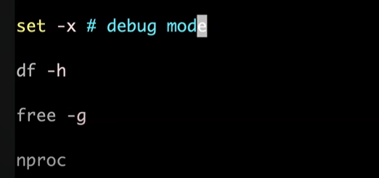

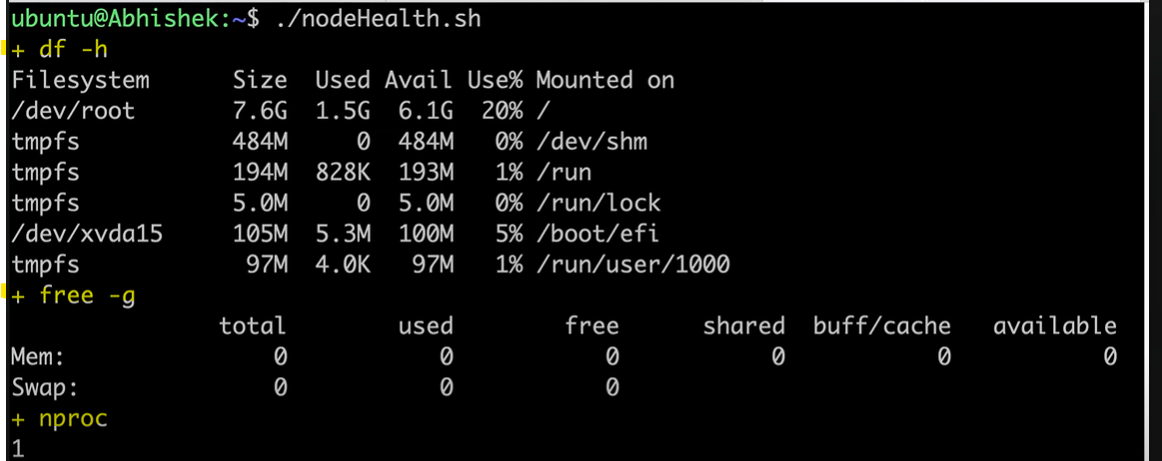

How to list and find process ?

Ps -ef -- It will show all process running

Any particular process status ?

Ps -ef | grep “amazon”

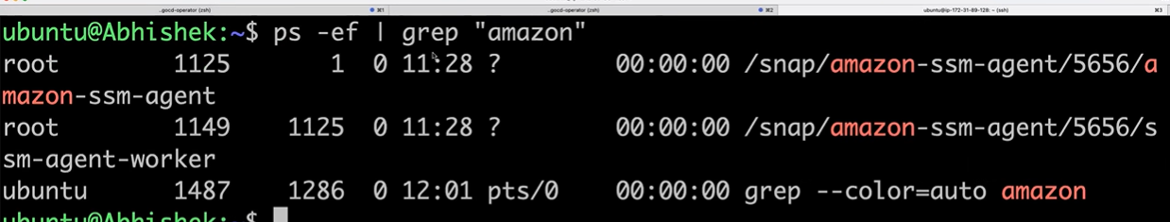

| --Pipe is sense the first command to the second command.

%%Interview question%%

Date is default command, it send information to stdin but pipe will not able to receive the output from stdin

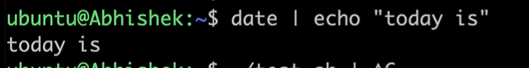

AWK – Pattern scanning and processing language

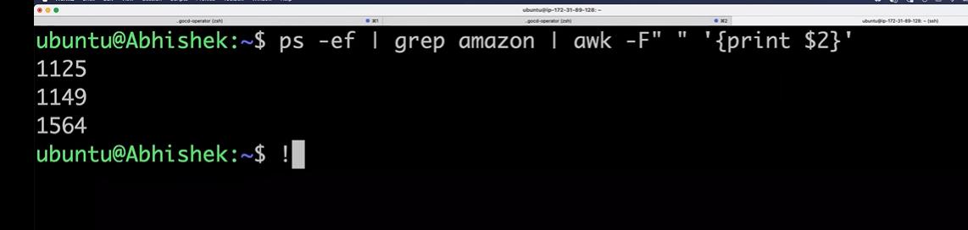

Set -e # exit the script when there is an error

Set -o

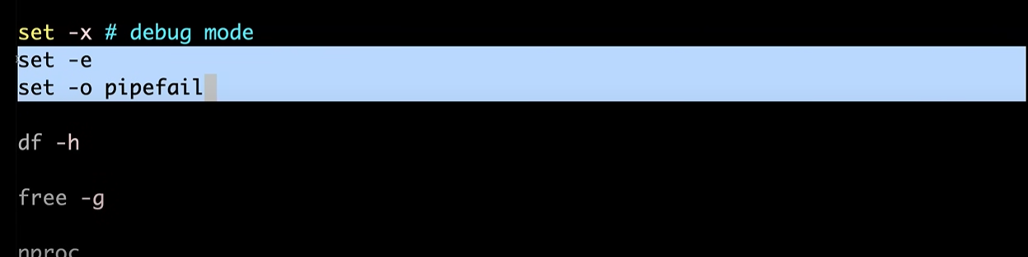

Unknown command so its failed

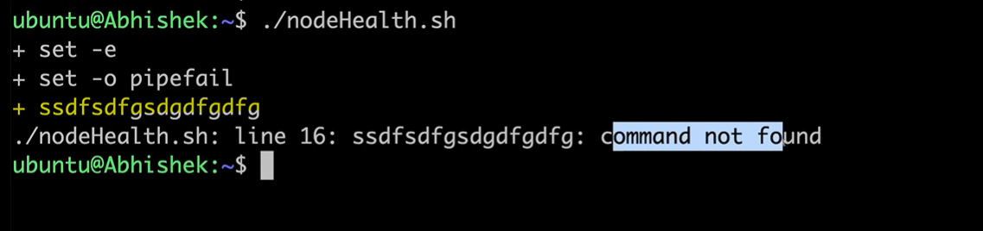

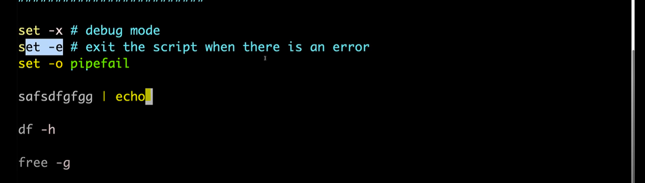

How to search error logs in remote files

Curl – retrives the information from interne

Curl (S3 link) (git hub link)(azure blob link)

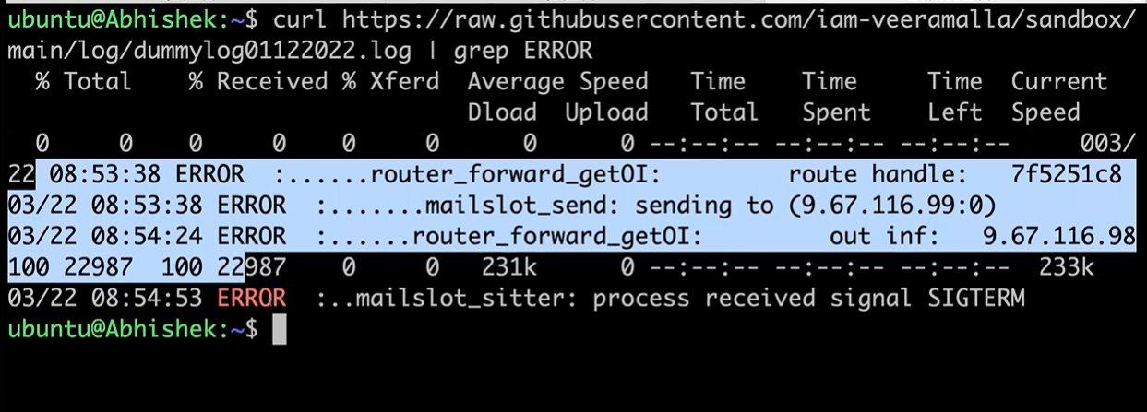

wget (S3 link) (git hub link)(azure blob link)

will download the log file

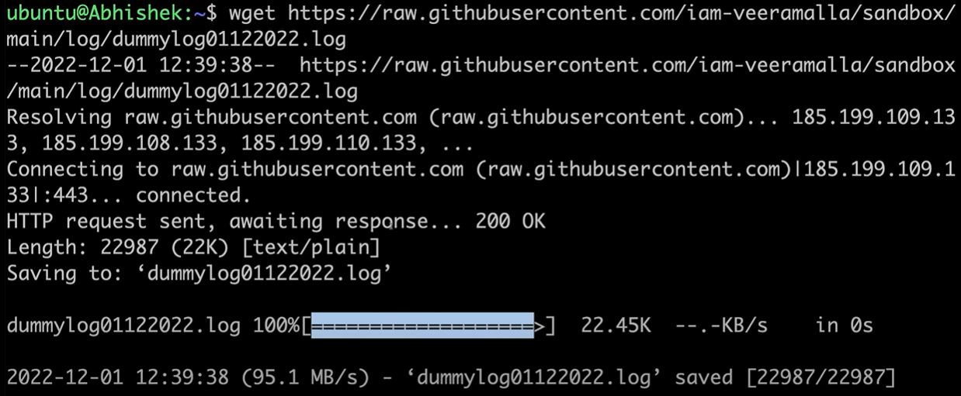

Curl vs wget – interview question

This command will take to root user

Su – Switch user

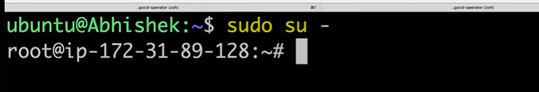

If we try like this we will get access denied

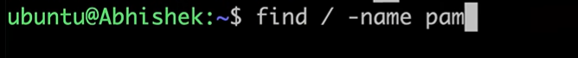

So we need to add sudo in front of it

